**Results for Stock Data (Year 2014)**

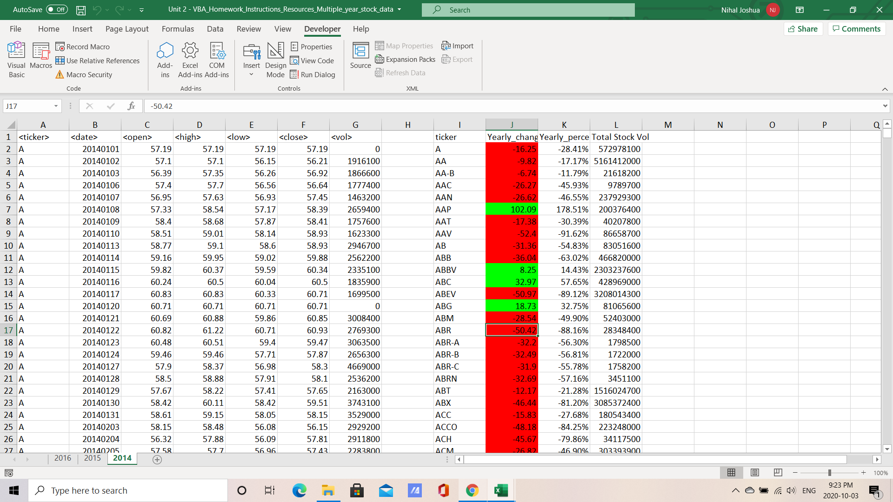

**Results for Stock Data (Year 2015)**

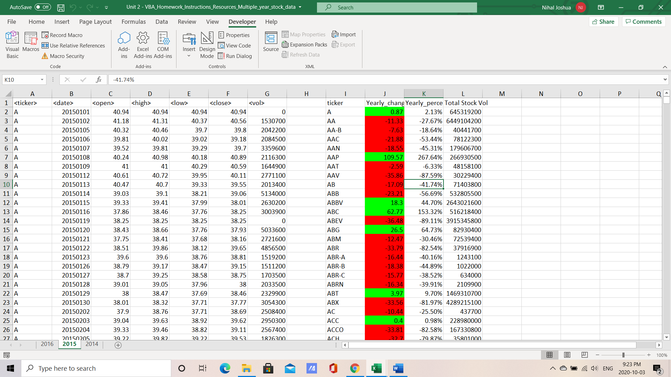

**Results for Stock Data (Year 2016)**

